ABSTRACT

AI based discourse for banking is an artificial intelligent development for banking operations, which can understand people queries and responds accordingly. The main aim of this project is to develop a banking bot using artificial intelligent algorithms which should be able to analyze and understand user’s queries and react accordingly. For any banking related queries we have to go to the bank or call to customer care. It takes lot of time and effort and bank people are also very busy to attend our queries. On the other hand we don’t get complete information from the customer care executives. It will be more suitable if we can directly post our queries online or chat with the bank people and get the response within less time. To overcome this problem we proposed banking bot where people can directly chat with a bot and they can integrate all of their bank accounts into same bot account and access them easily. In this Banking bot, we have included the five basic bank operations namely Savings, Current account, Loan enquiry, General queries, Net banking . In addition, users can post any query regarding the banking operations.

TABLE OF CONTENTS:-

INTRODUCTION

  - Overview

Purpose

LITERATURE SURVEY

Existing Problem

  - Proposed Solution

THEORETICAL ANALYSIS

  - Block Diagram

Software Designing

EXPERIMENTAL INVESTIGATION

FLOWCHART

RESULT

ADVANTAGES AND DISADVANTAGES

APPLICATIONS

CONCLUSION

FUTURE SCOPE

BIBLIOGRAPHY APPENDIX

- SOURCE CODE
- HTML CODE

TABLE OF CONTENTS
  - INTRODUCTION 1
  - LITERATURE SURVEY 1
  - THEORETICAL ANALYSIS 2
  - EXPERIMENTAL INVESTIGATION 2
  - FLOWCHART 2
  - RESULT 4
  - ADVANTAGES AND DISADVANTAGES 5
  - APPLICATIONS 5
  - CONCLUSION 6
  - FUTURE SCOPE 6
  - BIBLIOGRAPHY APPENDIX 6
    - INTRODUCTION

  - OVERVIEW:

In this our banking bot, our main objectives are as Follows:
- To ensure easier banking process.
- To minimize the time consumption.
- To has 24*7 accesses to the bank.
- Has eliminated most of the flaws in the existing chat bot applications.

  - PURPOSE:
To develop a banking bot using artificial intelligent algorithms which should be able to analyze and understand user’s queries and react accordingly.

2. LITERATURE SURVEY

  - Existing problem
For any banking related queries we have to go to the bank or call to customer care. It takes lot of time and effort from the customer care executives. It will be more suitable if we can directly post our queries online or chat with the bank people and get the response with no time.

2.2Proposed Solution:
To overcome this problem we proposed banking bot where people can directly chat with the bot. The proposed system is Banking bot is an artificial intelligent develop for banking operations, who understand people queries and responds accordingly. The main aim of this project is to develop a banking bot using artificial intelligent algorithms which should be able to analyze and understand user’s queries and react accordingly.


3.THEORETICAL ANALYSIS:
3.1Block Diagram:
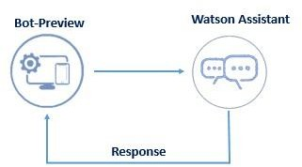

3.2Hardware / Software Designing:
        - Strategy: Using Watson Assistant Service for creating a chatbot.
        - Scripting of chatbot
          - Savings account
          - Current account
          - Loan enquiry
          - General queries
          - Net banking 3.Importing Libraries 4.Creating flask application 5.Build HTML code
6.Run Application

EXPERIMENTAL INVESTIGATION:

The main aim of this project is to develop a banking bot using artificial intelligent algorithms which should be able to analyze and understand user’s queries and react accordingly.

5.FLOWCHART:

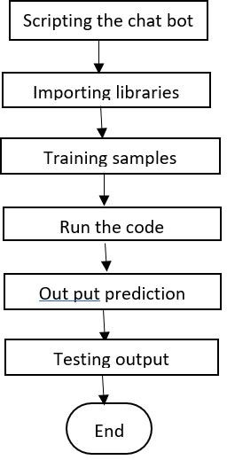
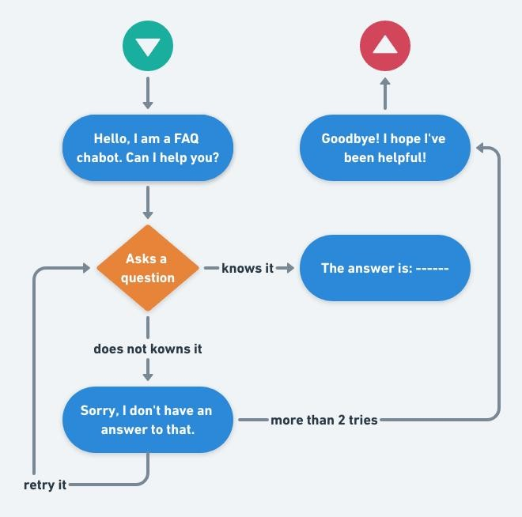

RESULT:
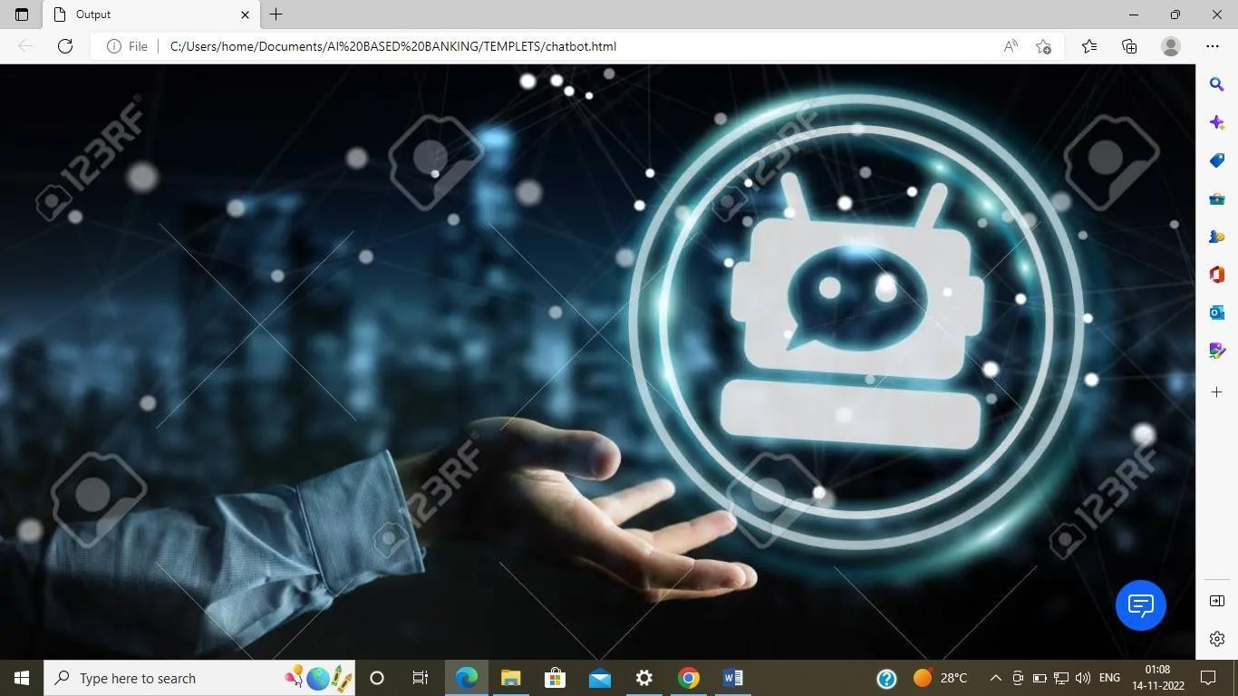
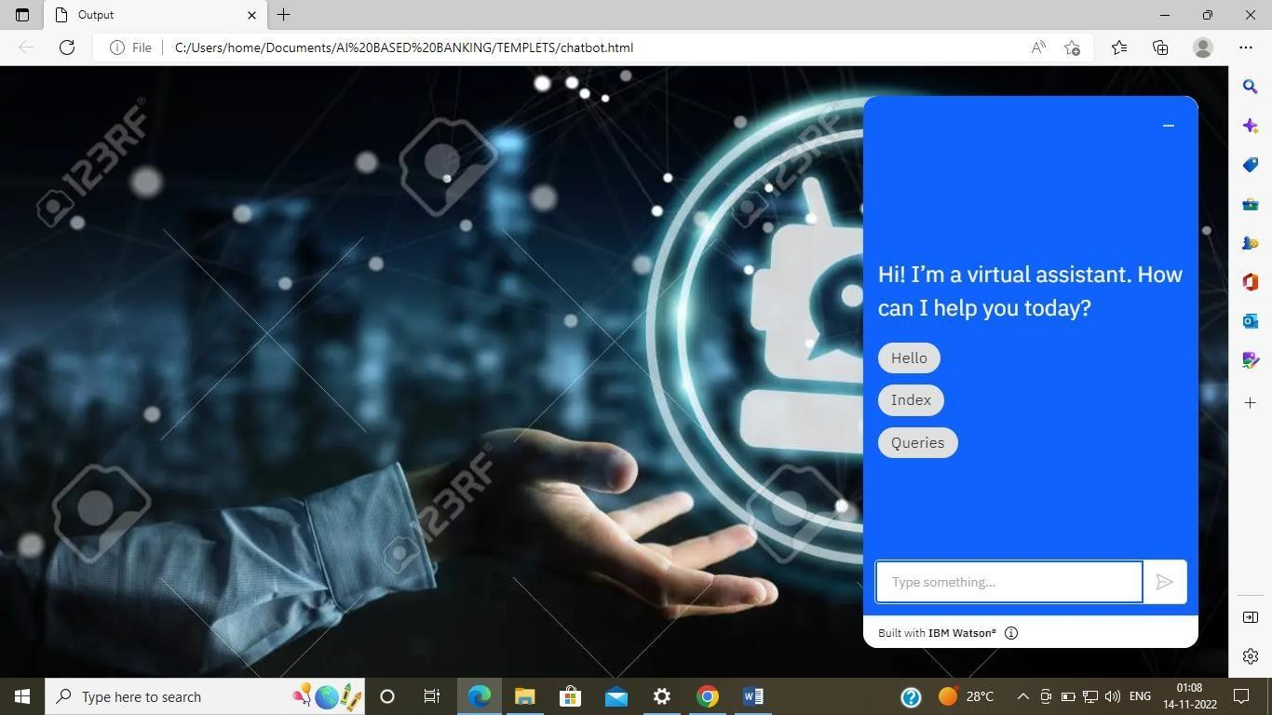

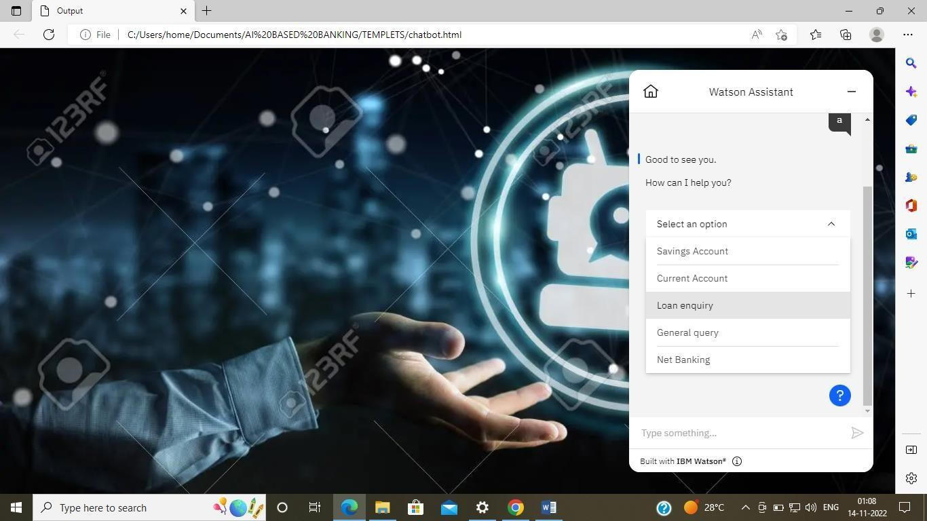

- ADVANTAGES AND DISADVANTAGES:

ADVANTAGES:
- Fast –paced communication
- Round the clock support
- Enhanced productivity of bank personnel
- More convenient mode of communication
- Providing a personalized experience for clients

DISADVANATAGES:

- Lack of human emotion and intelligence
- Limited functionality
- Not interpreting the question correctlu
- Not fully equipped to deal with real life scenarios

APPLICATIONS:
- Answer customer queries.
- Tailored financial advice.
- Cross-selling.
- Fraud prevention.
- Personalized service.
- Authentication mechanisms.

8.CONCLUSION:
Thus this project banking bot will be more efficient while it is been put into practice and it helps the customers to easily perform the user’s action of performing various banking tasks. It allows the user having various bank accounts to integrate into a single interface and he/she can add their account details into this bot account and easily perform their banking operations within seconds. The user will definitely have accounts in various banks. It will be tedious for the user to login to the various internet banking site every time so this bot will be handy at this situation and it is interactive too

9.FUTURE SCOPE:
The extraction of the iceberg detection from the satellite imagery can be used in

  - Digital cartography updating

  - Multi-temporal change analysis

  - Content-based image indexation

8BIBLOGRAPHY:
Application Building
- IBM Watson.
- Flask
4. HTML CODE

SOURCE CODE:

from flask import Flask,render_template app = Flask( name )
@app.route('/') def bot(): return render_template('html.html')

if app.run()
name ==' main ':

HTML CODE:
<!DOCTYPE html>
<html lang="en">
<head>
<meta charset="UTF-8">
<title>Output</title>
<link rel="stylesheet" href="https://cdn.jsdelivr.net/npm/bootstrap@4.4.1/dist/css/bootstrap.min.css" integrity="sha384- Vkoo8x4CGsO3+Hhxv8T/Q5PaXtkKtu6ug5TOeNV6gBiFeWPGFN9MuhOf23Q9Ifjh" crossorigin="anonymous">
<style>
body
{
background-image: url("https://previews.123rf.com/images/sdecoret/sdecoret1709/sdecoret170901746/86924478- businessman-on-blurred-background-chatting-with-chatbot-application-3d-rendering.jpg");
background-size: cover;
}
</style>
</head>
<body>
<script> window.watsonAssistantChatOptions = {
integrationID: "70a70473-8ea6-4b11-8623-506d0264eafc", // The ID of this integration. region: "us-south", // The region your integration is hosted in.
serviceInstanceID: "9c1d066b-3ba4-4a13-8b06-0e5d6c882db2", // The ID of your service instance. onLoad: function(instance) { instance.render(); }
};
setTimeout(function(){
const t=document.createElement('script');
t.src="https://web-chat.global.assistant.watson.appdomain.cloud/versions/" + (window.watsonAssistantChatOptions.clientVersion || 'latest') + "/WatsonAssistantChatEntry.js";
document.head.appendChild(t);
});
</script>
</body>
</html>

